CONCERTS

Saturday Afternoon
2:25 – 6:00
2:30 – 3:15 The Laners
3:20 – 4:05 Douglas/Moss
4:20 – 5:05 Andy Connally
5:10 – 5:55 Redmayne
Saturday Evening
7:25 – 11:00
7:30 – 8:15 Nick/Eleanor
8:20 – 9:05 Snapes/Poppy
9:20 – 10:05 Drop the Floor
10:10 –10:55 Litany

Sunday Afternoon
1:30 – 4:45
1:30 – 2:15 Glyn Shipman
2:20 – 2:50 Matilda Trio
3:05 – 3:50 Steve Canavan
3:55 – 4:40 Bandersnatch

CEILIDH
Friday 7:30 – 11 Change of Key Ceilidh Band

CATERING
Fri Supper 9 – 9:45
Pasties(meat, vegan, cheese), peas, red cabbage

Sat Breakfast 10 - 12
Barms(bacon, sausage, egg), teacakes, toast

Sat Lunch 12 - 4
Jackets, toasties, butties, pasties, vegan wraps, salad

Sat Tea 5:45 – 7:15
Veg curry, chilli con carne, pasties, beef lasagne, garlic bread, salad

Sun Breakfast 10 - 12
Barms(bacon, sausage, egg), teacakes, toast
Sun Lunch 12 – 4
Jackets, toasties, butties, pasties, vegan wraps, salad

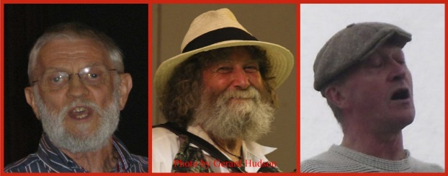
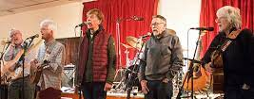
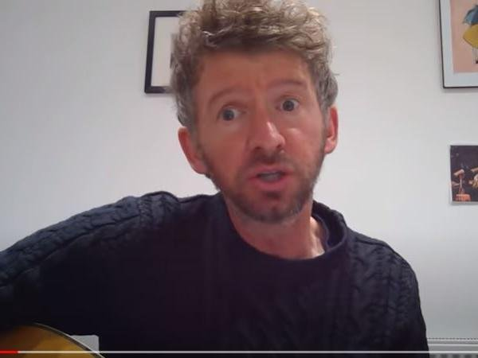
ARTISTS
Redmayne
Deservedly popular since the
sixties, with a cappella or expertly accompanied songs , often with complex harmonies
The Laners
A cappella group with attitude—English
traditional & shanties
Steve Canavan
Northern singer-songwriter performing his own witty, topical and thought-provoking ditties.

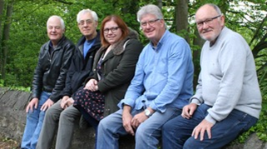
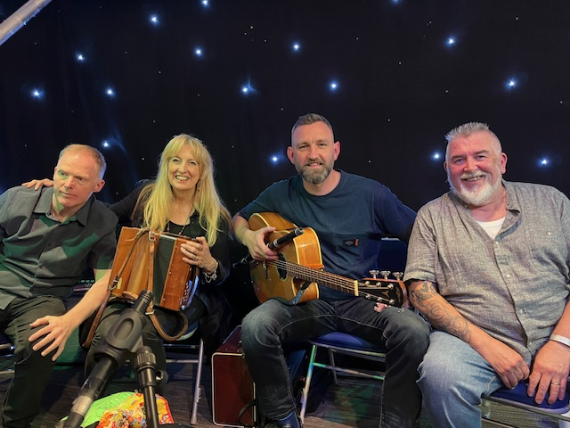
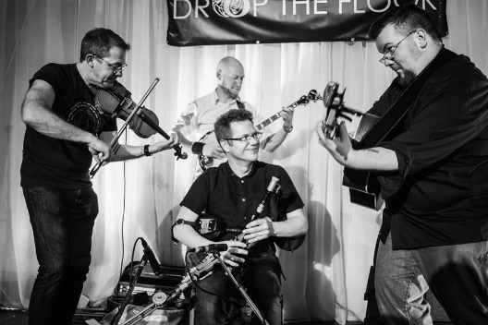
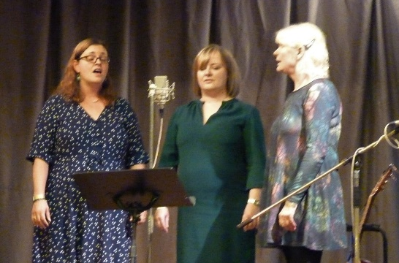
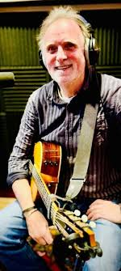
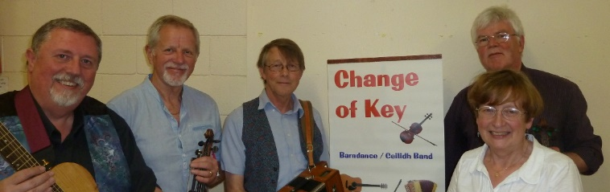
Bandersnatch
Feel good folk-rock band featuring vocals, guitar, fiddle, bass, mandolin and more with plenty to singalong to
Andy Connally
Ace singer, songwriter and multi-instrumentalist in his own right—kingpin of Wet the Tea

Drop the Floor
Three Lancashire lads and a Scotsman, instrumental maestros all, bring us vibrant Irish music and some stunning songs
The Matilda Trio
Beautiful harmonies, rousing choruses and inspiring song choices from this three piece a cappella group

Glyn Shipman
Song-writer , folk wordsmith and guitarist Glyn sings self-penned songs, popular at our monthly singarounds
Change of Key Ceilidh Band
Energetic and varied dance music from
this band of skilled local musicians for your Friday night shindig .
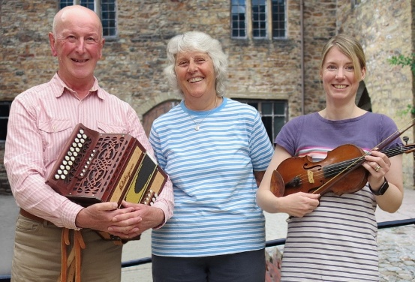
Peter & Barbara Snape / Poppy Weatherall
Peter & Barbara Snape / Poppy Weatherall – known for their fine singing and playing, varied, interesting and enjoyable mainly northern British songs from
the powerful to the poignant..

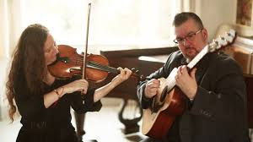
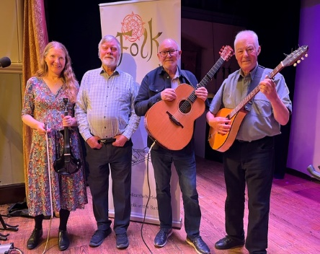
WORKSHOP SCHEDULE
Friday
8:00-11:00 Festival Folk Club Simon/Jamie Library
8:00-11:00 Informal Tunes Session Anne/Robin Reading Room
Saturday
10:30-11:45 Irish Dancing Jemma Hall
10:30-11:45 Celtic Songs/Tunes Fiach Library
10:30-11:45 Children’s Stories Sue Billiard Room

12:00-1:10 “Try a dulcimer”. Nonesuch Dulcimers Library
12:00-1:10 Percussion Andrew C/ David H Billiard Room.
12:00-1:10 “Icebound” presentation. Geoff / Nick / Simon Hall
1:15-2:15 Tunes Session Nonesuch Dulcimers Billiard Room.
1:15-2.15 Skiffle / Americana session The Dodgers Library
6:00-7.15 Shanties & Songs of the sea. Harrison Library
6.00-7.15 Informal tunes session Anne & Robin Reading Room
Sunday
11:00-12:30 Tunes Session Gill / Dave Hall
11:00-12:00 Song Session Simon / Jamie Library
12:15-1:15 “Last man standing” Songs David Hamflett Library

Douglas/Moss
Talented duo Clare and
Richard with self-penned and traditional tunes and songs in innovative arrangements .

Litany
Interesting renditions of well-selected old
favourites. Great
vocals—
with guitar,mandolin and fiddle
accompanying.
New band.
FESTIVAL SCHEDULE Friday
7:30—11 Ceilidh, Tunes, Festival Folk Club

7:30—11 Ceilidh, Tunes, Festival Folk Club

7:30—11:00 Ceilidh, Tunes, Festival Folk Club

Saturday
10:30—2:15 Workshops & Sessions
2:30—6:00 Concert
6:00—7:15 Workshops & Sessions
7:30—11:00 Concert

7

7:30—11;00 Concert

Sunday
11—1:15 Workshops & Sessions
1:30—4:45 Concert

