
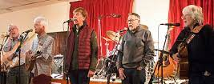
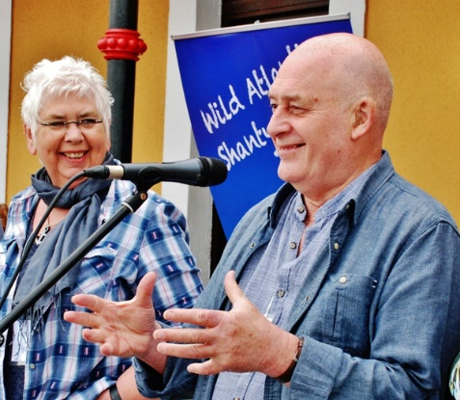
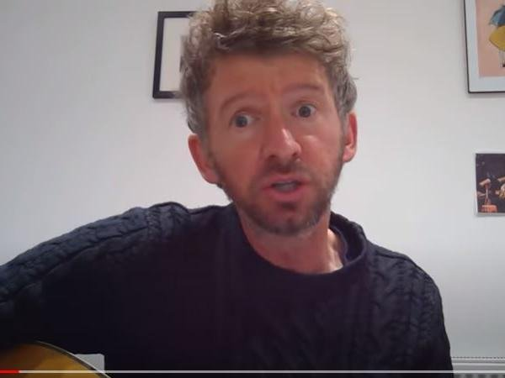
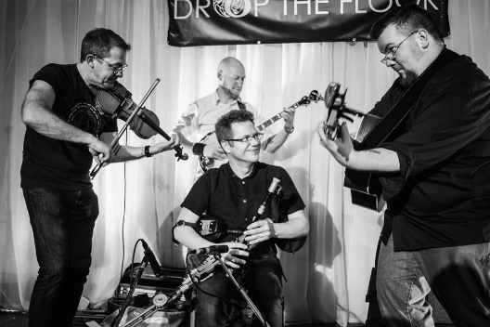
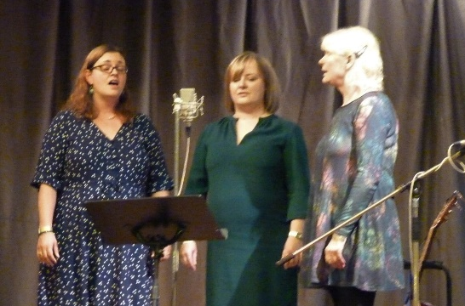
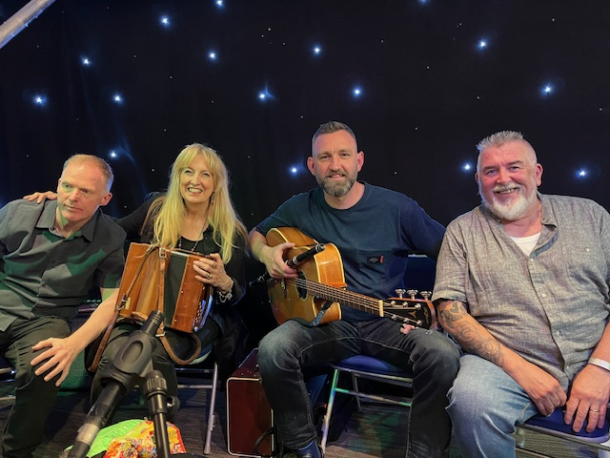
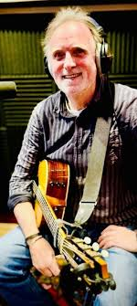
FESTIVAL ARTIST INFORMATION
Redmayne
Deservedly popular since the
sixties, with a cappella or expertly accompanied songs , often with complex harmonies
The Laners
A cappella group with attitude—English
traditional & shanties
Steve Canavan
Northern singer-songwriter performing his own witty, topical and thought-provoking ditties.
LocTup Together
Chris Lock and Ian Tupling - varied and inspiring repertoire including maritime songs and shanties Two wonderfully powerful voices in close harmony.
Drop the Floor
Three Lancashire lads and a Scotsman, instrumental maestros all, bring us vibrant Irish music and some stunning songs
The Matilda Trio
Beautiful harmonies, rousing choruses and inspiring song choices from this three piece a cappella group

Andy Connally
Ace singer, songwriter and multi-instrumentalist in his own right—kingpin of Wet the Tea

Glyn Shipman
Song-writer , folk wordsmith and guitarist Glyn sings self-penned songs, popular at our monthly singarounds
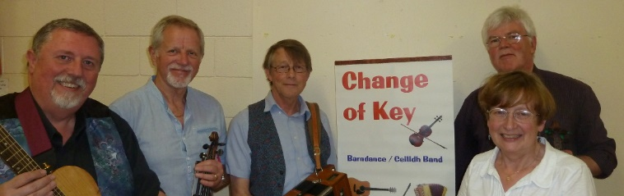
Change of Key Ceilidh Band
Energetic and varied dance music from
this band of skilled local musicians for your Friday night shindig .

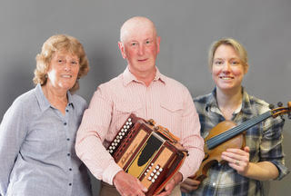
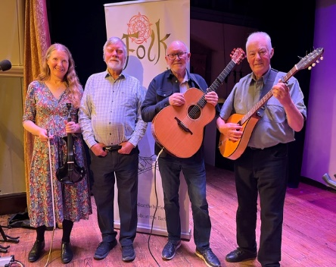
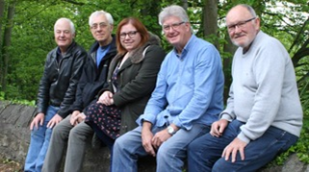
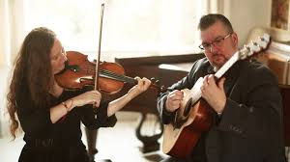
Peter & Barbara Snape / Poppy Weatherall
Lancashire to the core with rousing songs, humour, dialect, poignant songs, great choruses and foot-tapping melodeon.
FESTIVAL SCHEDULE Friday
7:30—11 Ceilidh, Tunes, Festival Folk Club

7:30—11 Ceilidh, Tunes, Festival Folk Club

7:30—11:00 Ceilidh, Tunes, Festival Folk Club

Saturday
10:30—2:15 Workshops & Sessions
2:30—6:00 Concert
6:00—7:15 Workshops & Sessions
7:30—11:00 Concert

7

7:30—11;00 Concert

Sunday
11—1:15 Workshops & Sessions
1:30—4:45 Concert
Redmayne
Deservedly popular since the
sixties, with a cappella or expertly accompanied songs , often with complex harmonies
Bandersnatch
Feel good folk-rock band featuring vocals, guitar, fiddle, bass, mandolin and more with plenty to singalong to
Douglas/Moss
Talented duo Clare and
Richard with self-penned and traditional tunes and songs in innovative arrangements .

Litany
Interesting renditions of well-selected old
favourites. Great
vocals—
with guitar,mandolin and fiddle
accompanying.
New band.

